SpAces: visualising inclusion and belonging
Clare Woolhouse, Virginia Kay, linda dunne Charlotte Hastings and Fiona HalleTt

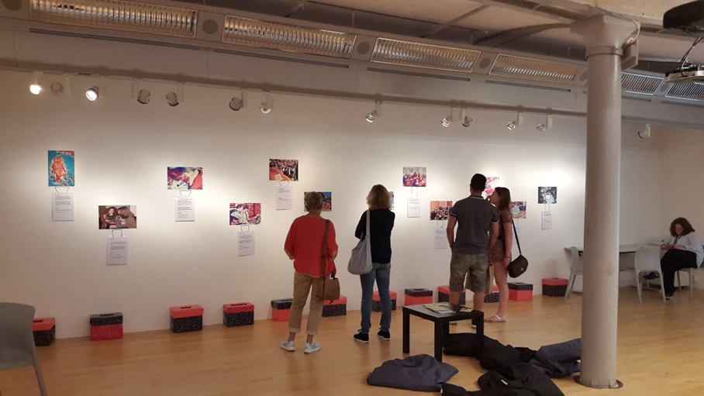
This event involved a collaborative week-long residency during June 2018 in the Exchange Gallery Space and daily workshops in the Clore Learning Studio at Tate Liverpool. The event built on the ‘Research in Special Education’ (RISE) project which involves staff from across the departments within the Faculty of Education.
SpAces was designed to interactively explore the views and experiences of belonging and social inclusion through the display of cartoonised photographs taken by children and young people and is part of the broader RISE project.
To produce the images that formed the exhibit, children and young people in four schools in North West England and the Isle of Man were invited to take photographs that they felt represented inclusion or exclusion and explain their choice. The photographs were ‘artified’ using software to anonymise participants for ethical reasons and were then shared with other children, young people and teachers, who offered their interpretations of social inclusion and exclusion within education.
A selection of these images and the interpretations offered by those who have viewed them so far formed the basis of the display at Tate Liverpool to invite active, collaborative engagement from gallery visitors of all ages. The aim of the exhibit was to facilitate exchanging insights from a wide audience about a broad range of experiences and opinions relating to social inclusion and exclusion.
Visitors to the gallery and those who took part in the workshops in the Clore Studio were invited to engage with the photographs displayed and comment on them. We received over 1,000 engagements on twitter and over 200 comments cards were submitted within the Gallery.
The aim of the event was to actively engage visitors and encourage them to create artefacts and images to add to the event. At one end of the Tate Exchange Gallery a ‘wish shelf’ was set up and visitors were invited to create an origami sculpture of a crane which represents peace, and to add it to the shelf. In total 84 cranes were created along with 29 other forms which included boats, hats and planes, various animals and abstract sculptures.
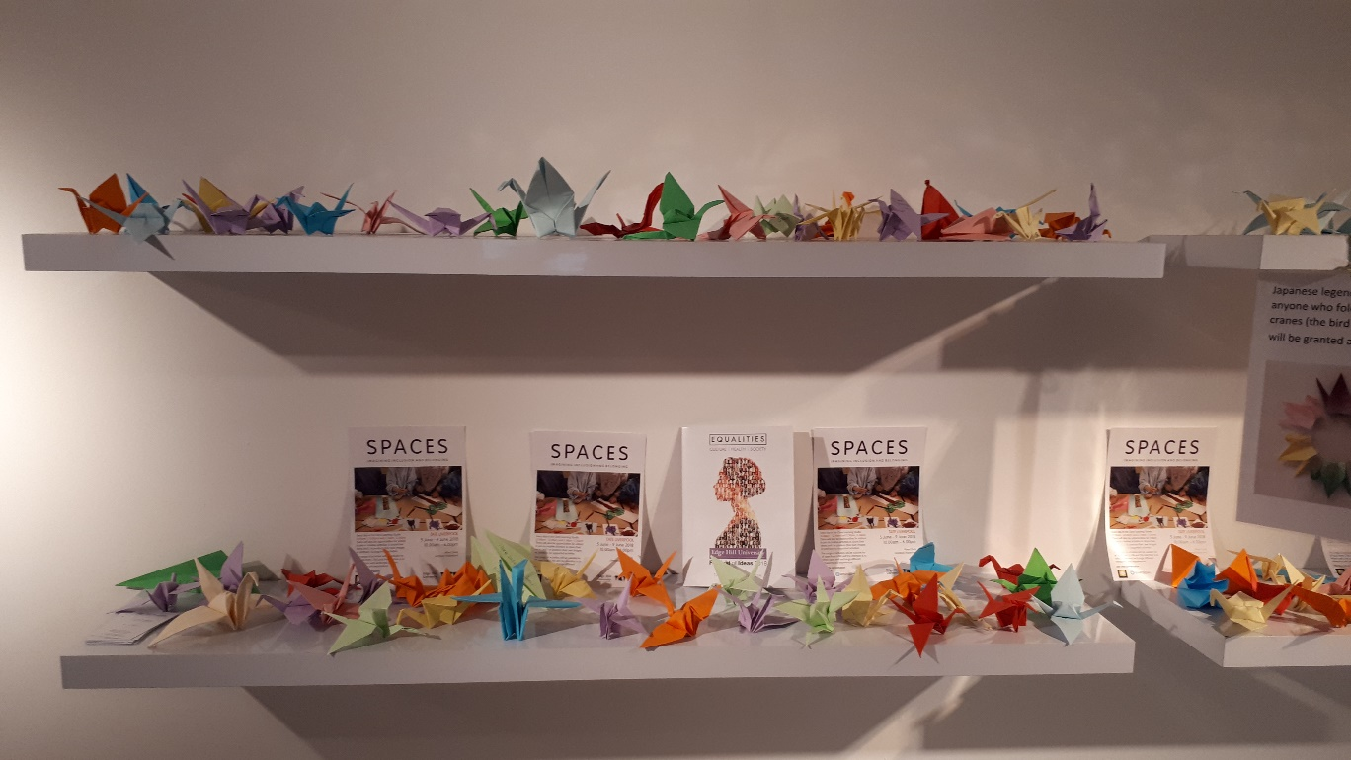

Within the Gallery space and the Clore Studio visitors were also invited to signal their support for belonging to a diverse and inclusive community by adding a self-portrait to a community wall display titled: ‘creating a welcoming community’. Over the course of the week 113 portraits were added to the wall.
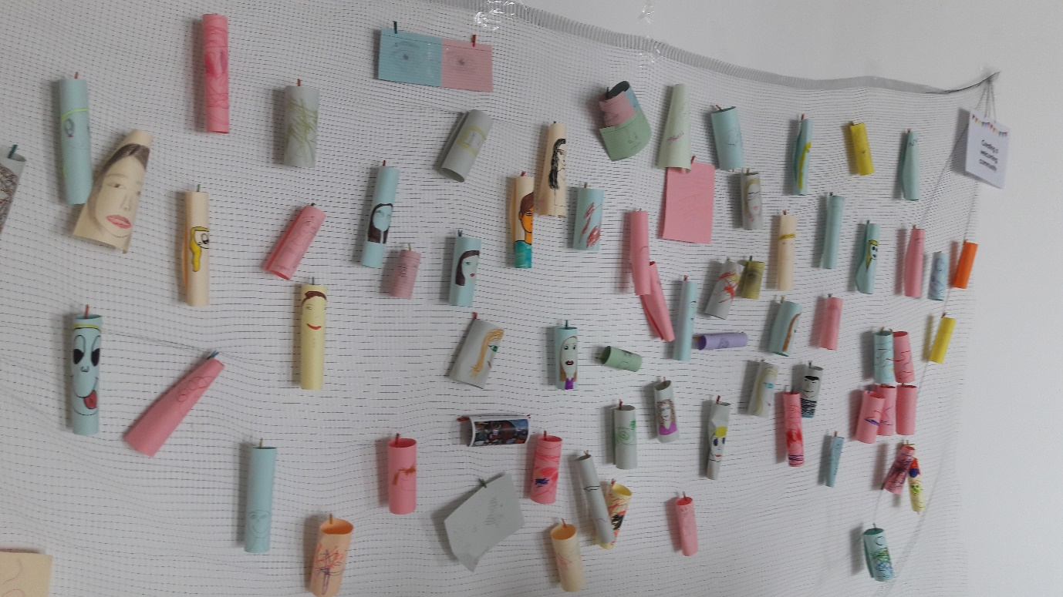

All the researchers involved in this event very much enjoyed their time at Tate Liverpool and would encourage any academic colleagues who have research that they feel should be shared with the wider public consider engaging in non-academic spaces such as museums or art galleries.
You can join the conversation at: Twitter: @INRISEEHU
You can read more about this ongoing project:
Woolhouse, C. in press & on line. Conducting photo methodologies: framing ethical concerns relating to representation, voice and data analysis when exploring educational inclusion with children. International Journal of Research and Method in Education.
http://dx.doi.org/10.1080/1743727X.2017.1369511

Dunne, L., Hallett, F., Kay, V. and Woolhouse, C. 2018. Spaces of inclusion: Investigating place, positioning and perspective within educational settings through photo-elicitation. International Journal of Inclusive Education. 22 (1) pp. 21-37. http://www.tandfonline.com/doi/full/10.1080/13603116.2017.1348546
Woolhouse, C., Dunne, L., Hallett, F., and Kay, V. 2017. Perceptions of inclusion. Inclusion Now. Published by Alliance for Inclusive Education (ALLFIE), Spring 2017 (46): 9-11.
http://www.allfie.org.uk/blog/what-does-inclusion-look-like/
Dunne, L., Hallett, F., Kay, V. and Woolhouse, C. 2017. Visualising Inclusion: Employing a photo-elicitation methodology to explore views of inclusive education, SAGE Research Methods Cases. Part 2. http://methods.sagepub.com/case/visualizing-inclusion-photo-elicitation-methodology-inclusive-education

For further information please contact:
Dr Clare Woolhouse, Reader, Faculty of Education, Woolhouc@edgehill.ac.uk

