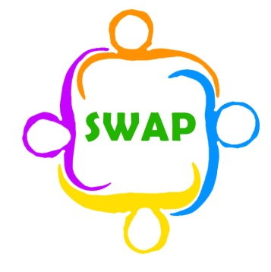
Support for Wigan Arrivals Project
Volunteer Role Description
(English Conversation)

Location of position | Penson Street
Responsible to | Emma Atherton and Mick Taylor
Purpose of role | To help teach English to Asylum Seekers and Refugees
Description of tasks | To prepare for English Conversation Classes before the class starts on either a Monday or a Wednesday afternoon, by reading the emails sent earlier on in the week.  To arrive at 1pm for the briefing and conversation with your fellow conversation teachers, when possible and stay till 3pm, this is with a 15-minute break at around 2pm.  To be friendly, helpful, and flexible throughout.  To be engaged in the week’s topic.
Time commitment | 1 or 2 days a week
Skills & Qualities | Fluent grasp of English, reading, writing and speaking  Good communication skills.  Ability to interact with people from different backgrounds and people who don’t speak English.  Patience.  Interest in learning off people from different backgrounds.  Compassion.
Training and support | Induction done with Emma. Regular volunteer’s meetings are held to give a space to discuss the volunteer experience at SWAP (This can be done at the volunteer briefing)
Expenses | Any travel expenses and 50p per hour for food reimbursement (these are given on request)
Benefits to volunteer | Access to any in house training opportunities for free  Work with people from around the world in a role where no one day is the same. Working at SWAP is always a rollercoaster ride, you will meet people, learn things, and experience things you never thought you could do in Wigan.  Get experience of teaching English to foreign language speakers.
Application procedure | Please email Emma for an application form and state which role you are interested in applying for
Contact information | Emma Atherton  E: emma@swapwigan.org  T: 01942 516572

